
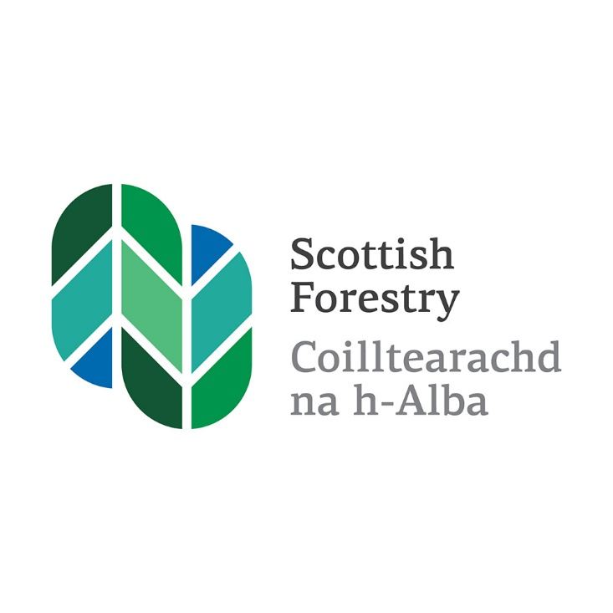

Future Grant Support for Forestry
Respondent Information Form
February 2023
Scottish Forestry is the Scottish Government agency responsible
for forestry policy, support and regulation
Is e Coilltearachd na h-Alba a’ bhuidheann-ghnìomha aig Riaghaltas
na h-Alba a tha an urra ri poileasaidh, taic agus riaghladh do choilltearachd

Future Grant Support for Forestry

Respondent Information Form

Please Note this form must be completed and returned with your response.
To find out how we handle your personal data, please see our privacy policy:

Privacy – Scottish Forestry (www.forestry.gov.scot)
Are you responding as an individual or an organisation?
Individual
Organisation
Full name or organisation’s name

Phone number
Address

Postcode

Email Address
Information for organisations:
The option 'Publish response only (without name)’ is available for individual respondents only. If this option is selected, the organisation name will still be published.
If you choose the option 'Do not publish response', your organisation name may still be listed as having responded to the consultation in, for example, the analysis report.

The Scottish Government would like your
permission to publish your consultation response. Please indicate your publishing
preference:

Publish response with name
Publish response only (without name)
Do not publish response

We will share your response internally with other Scottish Forestry policy teams who may be addressing the issues you discuss. They may wish to contact you again in the future, but we require your permission to do so. Are you content for Scottish Forestry to contact you again in relation to this consultation exercise?
Yes
No

Responding to this consultation

We are inviting responses to this consultation by 17 May 2023.

Please respond to this consultation using the Scottish Forestry’s consultation hub, Citizen Space (Scottish Forestry - Citizen Space (https://scottishforestry.citizenspace.com)).
Access and respond to this consultation online at https://scottishforestry.citizenspace.com.

You can save and return to your responses while the consultation is still open. Please ensure that consultation responses are submitted before the closing date of 17 May 2023.
If you are unable to respond using our consultation hub, please complete the Respondent Information Form and send to:
FGS Consultation
Scottish Forestry
Silvan House
231 Corstorphine Road
Edinburgh, EH12 7AT

You can also email the Respondent Information Form to grantconsultation@forestry.gov.scot

Question 1
Do you agree that grant support for forestry should continue to be improved and developed as a discrete scheme within the overall package of land support?
Yes
No
Not Sure
Please explain your answer in the text box.

Question 2
Are there any changes that would allow for better complementarity between the forestry and agriculture funding options?
Yes
No
Not Sure
Please explain your answer in the text box.

Question 3
How can the support package for forestry evolve to help tackle the climate emergency, to achieve net zero, and to ensure that our woodlands and forests are resilient to the future climate?
Please explain your answer in the text box.

Question 4
Private investment through natural capital and carbon schemes can make a valuable contribution to climate change.
Do you agree that the grant support mechanism should have more flexibility to maximise the opportunities to blend private and public finance to support woodland creation, and if so, how might this be achieved?
Yes
No
Not Sure
Please explain your answer in the text box.

Question 5
How could the current funding package be improved to stimulate woodland expansion and better management across a wide range of woodland types, including native and productive woodlands?
Please explain your answer in the text box.

Question 6
Do you agree that it should be a requirement of grant support that woodlands are managed to ensure that they become more resilient to the impacts of climate change and pests and disease?
Yes
No
Not Sure
How can the grant scheme support this?

Question 7
Which of the following measures would help reduce the barriers for crofters and farmers wanting to include woodland as part of their farming business? Please select all that apply.
Better integration of support for woodland creation with farm support mechanisms
Knowing where to get reliable advice
Clearer guidance on grant options
Flexibility within options
Intervention level
Support with cashflow
Information on how current land use could continue with trees integrated throughout

Are there others not listed above?

Question 8
Establishing small woodlands can have higher costs. What specific mechanisms would better support small scale woodlands and woodland ownership?
Please explain your answer in the text box.

Question 9
How can forestry grants better support an increase in easily accessible, sustainable managed woodlands in urban and peri-urban areas?
Please explain your answer in the text box.

Question 10
How can grant support for forestry better enable rural communities to realise greater benefits from woodland to support community wealth building?
Please explain your answer in the text box.

Question 11
How can the forest regulatory and grant processes evolve to provide greater opportunities for communities to be involved in the development of forestry proposals?
Please explain your answer in the text box.

Question 12
How can the forestry regulatory and grant processes evolve to ensure that there is greater transparency about proposals and the decisions that have been made on them?
Please explain your answer in the text box.

Question 13
Forestry grants have been used to stimulate rural forestry businesses by providing support with capital costs. Do you agree that this has been an effective measure to stimulate rural business?
Yes
No
Not Sure
- How could this approach be used to support further forestry businesses?

- How could this approach be used to support further skills development?

Question 14
How could the FGS processes and rules be developed to encourage more companies and organisations to provide training positions within the forestry sector?
Please explain your answer in the text box.

Question 15
The primary purpose of FGS is to encourage forestry expansion and sustainable forest management, of which a key benefit is the realisation of environmental benefits. How can future grant support better help to address biodiversity loss in Scotland including the regeneration and expansion of native woodlands?
Please explain your answer in the text box.

Question 16
Herbivore browsing and damage can have a significant impact on biodiversity loss and restrict regeneration. How could forestry grant support mechanisms evolve to ensure effective management of deer populations at:
Landscape scale?

Small scale mixed land use?

Question 17
If you wish to make any other relevant comments, please do so in the text box below.

